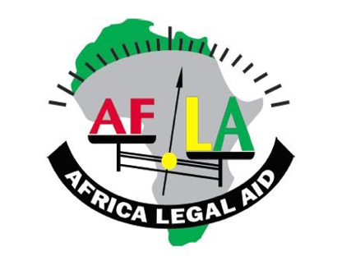

AFLA 2021
Africa Legal Aid (AFLA) has consistently worked to promote human rights and accountability in Africa, adopting a victim-centred approach to justice.
In November 2020, AFLA launched its project on ‘Gender-Sensitive Judging in International Criminal Courts with a focus on the ICC’. AFLA’s intervention aims to strengthen the judicial capacity of both male and female judges to help them deliver gender-sensitive justice. However, the initial meetings have targeted women judges so that they may take ownership of the project and build a foundation of shared experiences as female judges working in a multicultural environment. Through the sharing of female experiences, areas where female judges most need support have been revealed and will allow for focused strategies to address those needs.
Since the launch of the project just over a year ago, six meetings have been held, namely:
- Side Event at the 20th Session of the Assembly of States Parties (ASP) of the ICC on Gender-Sensitive Judging in International Criminal Courts (Co-hosted by Australia, the Netherlands, Uganda and Africa Legal Aid, December 2021).
- Consultations on Gender-Sensitive Judging in International Criminal Courts (November 2021).
- Gender Issues Concerning Approaches to Female Counsels (May 2021).
- Gender Issues Concerning Approaches to Female Victims and Witnesses (February 2021).
- Reflections on the (Generic) Recommendations in the Final Report of the Independent Expert Review of the ICC (December 2020).
- Gender Dynamics Within International Courts and Tribunals (November 2020).
AFLA further prepared narrative reports on each of the above referenced activities.

AFLA continued its efforts to support victims of serious crimes, particularly female victims of sexual and gender-based violence (SGBV), to ensure their meaningful participation in the justice process in Mali, Southern Africa, and The Gambia. Through advocacy, capacity building, and dissemination of information, AFLA continues to push for justice for victims of serious crimes of international concern committed in The Gambia during the 22-year reign of Yahya Jammeh.
Accordingly, in 2021 AFLA undertook the following activities on a victim-centred approach to justice in Mali, Southern Africa, and The Gambia:
- Produced comprehensive internal working documents on the need to strengthen Malian victims.
- Prepared background reading materials for participants who will attend a three-day workshop that will be held in Mali in 2022.
- Issued e-reporters on the position of female victims of SGBV in Mali.
- Engaged female survivors and victims of SGBV with women-led civil societies in Southern Africa, supporting them on pursuing their rights and seeking accountability against perpetrators.
- Convened Side Event at the 20th Session of the ASP on ‘Justice Must Happen for Gambia’ (Co-hosted by Uganda and Africa Legal Aid, December 2021).
- Consultations with AFLA partners in The Gambia to help them arrange and reach the vast population who was isolated due to the Covid-19 pandemic.
- Produced narrative report on ASP Side Event and consultations on The Gambia.
- Issued e-reporter on ‘Gambia Supreme Court Judgement Paves the Way for Accountability for Serious Crimes’.
23007,87 Eur private contributions went towards stipends and administrative costs.

